WEEK 4
AI Project Deployment & Capstone
Mall Customer Segmentation: a deployed Machine Learning application

1. Introduction
This capstone completes the four-week AI internship project. In Week 3 an unsupervised learning study grouped mall customers into segments. In Week 4 that work is turned into a complete, deployable machine learning application that covers data preprocessing, model training, evaluation, model serialization, a prediction API built with Flask, automated testing and cloud deployment instructions.
The business question is simple: given a customer's annual income and spending score, which marketing segment do they belong to, and how should the mall treat them?

1.1 Objectives
- Build an end-to-end ML project with preprocessing, training, testing and deployment.
- Serialize the trained model with Joblib.
- Expose the model through a web page and a JSON prediction API using Flask.
- Provide documentation and a presentation.

2. Dataset
The project uses Mall_Customers.csv, which contains 200 customers and five columns. The file does not state how the customers were sampled, over what period, or how the Spending Score was calculated; these gaps matter for the ethical discussion in Section 6.
Column | Type | Description
CustomerID | Integer | Unique customer identifier
Gender | Text | Male (88) or Female (112)
Age | Integer | Customer age in years
Annual Income (k$) | Integer | Annual income in thousands of dollars
Spending Score (1-100) | Integer | Score assigned by the mall based on behaviour

2.1 Data quality summary
Column | Min | Max | Mean | Std. dev.
Age | 18 | 70 | 38.8 | 14.0
Annual Income (k$) | 15 | 137 | 60.6 | 26.3
Spending Score (1-100) | 1 | 99 | 50.2 | 25.8
There are no missing values and no duplicate CustomerIDs. Age is weakly correlated with Spending Score (r = -0.33) and not correlated with Annual Income (r = -0.01). Income and Spending Score are also uncorrelated (r = 0.01), which is why the data forms separate, compact groups rather than one diagonal cloud.

3. Data Preprocessing
All preprocessing lives in train_model.py (load_and_clean) and in the request validator of app.py. Each step below shows the exact code, explains why it is needed and states what it did to this dataset.

Step 1: Load the file and normalise column names
df = pd.read_csv(path)
df.columns = [c.strip() for c in df.columns]
Why: stray spaces in a header (for example "Age ") silently break column lookups later. Result: all five column names were already clean.

Step 2: Check that the schema is what the model expects
required = ["CustomerID", "Gender", "Age"] + FEATURES
missing = [c for c in required if c not in df.columns]
if missing:
raise ValueError(f"Dataset is missing columns: {missing}")
Why: failing early with a clear message is better than a confusing error halfway through training. Result: schema valid.

Step 3: Remove duplicates and missing values
df = (df.drop_duplicates(subset="CustomerID")
.dropna(subset=required))
Why: a duplicated customer would be counted twice and pull a centroid towards itself; K-Means cannot handle NaN values at all. Result: 0 duplicates and 0 missing values were found, so no rows were dropped.

Step 4: Standardise categorical text
df["Gender"] = df["Gender"].str.strip().str.title()
Why: "male", "Male " and "MALE" would otherwise be counted as three categories in the profile and fairness tables. Result: 112 Female and 88 Male.

Step 5: Validate numeric ranges
df = df[df["Annual Income (k$)"].between(0, 1000)]
df = df[df["Spending Score (1-100)"].between(1, 100)]
df = df[df["Age"].between(10, 100)].reset_index(drop=True)
Why: impossible values such as a score of 250 or an age of -3 are data-entry errors and would distort the centroids. The limits are deliberately generous so real customers are never removed. Result: all 200 rows were within range (Age 18-70, Income 15-137, Score 1-99).

Step 6: Select the clustering features
FEATURES = ["Annual Income (k$)", "Spending Score (1-100)"]
X = df[FEATURES]
Why: Section 4.6 shows experimentally that adding Age or Gender lowers cluster quality. Gender is also a protected attribute, so leaving it out of the model is the safer ethical choice (Section 6). Age and Gender are kept in the table only to describe the segments afterwards.

Step 7: Scale the features inside the model pipeline
pipeline = Pipeline([
("scaler", StandardScaler()),
("kmeans", KMeans(n_clusters=5, n_init=10, random_state=42)),
])
pipeline.fit(X)
Why: K-Means uses Euclidean distance, so a feature measured in larger units would dominate. Putting the scaler inside the same Pipeline guarantees that a new customer sent to the API is scaled with exactly the training mean and standard deviation, and prevents training/serving mismatch. Honest note: on this dataset both features already have almost the same spread (standard deviation 26.3 and 25.8), so scaling does not change the result (Section 4.7). It is kept as a safeguard for when other features are added.

Step 8: Validate every prediction request
income = float(payload.get("annual_income"))
score = float(payload.get("spending_score"))
if not 0 <= income <= 1000: return error(400)
if not 1 <= score <= 100: return error(400)

X = pd.DataFrame([[income, score]], columns=[INCOME, SCORE])
cluster = int(model.predict(X)[0])
Why: a deployed API receives input from anyone. Missing, non-numeric or out-of-range values return HTTP 400 with a clear message instead of a meaningless prediction. Building a DataFrame with the original column names keeps the input identical in format to the training data. Six invalid-input cases are covered by automated tests.

4. Methodology

4.1 Why unsupervised learning
The dataset has no target column: nobody has labelled which marketing group each customer belongs to. The task is therefore unsupervised. The goal is to discover natural groups, not to predict a known label, so accuracy, precision and recall do not apply. Quality is measured with internal clustering metrics and judged by whether the segments make business sense.

4.2 How K-Means works
K-Means searches for K centroids that minimise the within-cluster sum of squares (inertia), the total squared distance from each customer to the centroid of its cluster. It repeats two steps until nothing changes: assign each customer to the nearest centroid, then move each centroid to the mean of its customers. The result depends on the starting centroids, so the model uses k-means++ initialisation, n_init=10 independent restarts (the best run is kept) and a fixed random_state=42 so results can be reproduced.

4.3 Evaluation metrics
- Silhouette score (range -1 to 1, higher is better): for each customer it compares the average distance to its own cluster with the average distance to the nearest other cluster. Values above 0.5 mean clearly separated groups.
- Davies-Bouldin index (0 and above, lower is better): the average similarity between each cluster and the cluster most like it, so low values mean compact, well separated clusters.
- Inertia (elbow method): measures compactness, but always falls as K grows, so it is only useful for spotting the point of diminishing returns.
All three are internal metrics: they measure geometry, not business value. They are therefore combined with the segment profiles in Section 5.

4.4 Choosing the number of clusters
K-Means was trained for K = 2 to 10. The elbow of the inertia curve and the peak of the silhouette score both point to K = 5. After K = 5 inertia improves only slowly and the silhouette score falls, meaning extra clusters just split natural groups.
K | Inertia | Silhouette
2 | 269.7 | 0.321
3 | 157.7 | 0.467
4 | 108.9 | 0.494
5 | 65.6 | 0.555 (best)
6 | 55.1 | 0.540
7 | 44.9 | 0.528
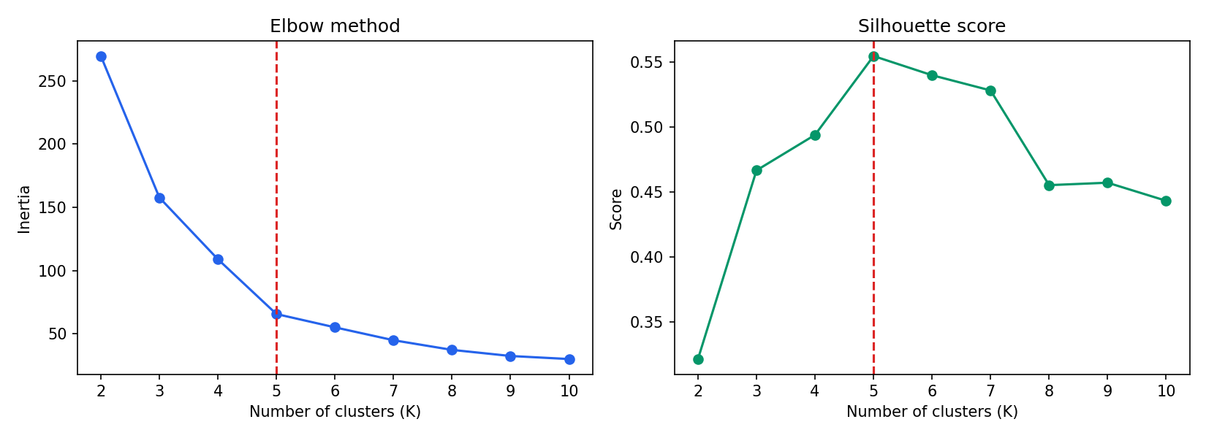
Figure 1: Elbow method and silhouette score for K = 2 to 10

4.5 Why K-Means? Comparing algorithms
To justify the choice, four other clustering methods were run on the same scaled data (compare_models.py). Gaussian Mixture and Ward hierarchical clustering were given K = 5. DBSCAN does not take K, so it was run with one reasonable setting (eps = 0.35, min_samples = 5) that was not exhaustively tuned.
Algorithm | Clusters | Noise points | Silhouette | Davies-Bouldin
DBSCAN (eps 0.35) | 6 | 23 | 0.558* | 0.511*
K-Means (K=5) | 5 | 0 | 0.555 | 0.572
Agglomerative, Ward | 5 | 0 | 0.554 | 0.578
Gaussian Mixture | 5 | 0 | 0.554 | 0.576
Agglomerative, Single | 5 | 0 | 0.276 | 0.423
* DBSCAN's scores are computed only on the 177 customers it kept; it labelled 23 customers (11.5%) as noise, so its numbers are not directly comparable.
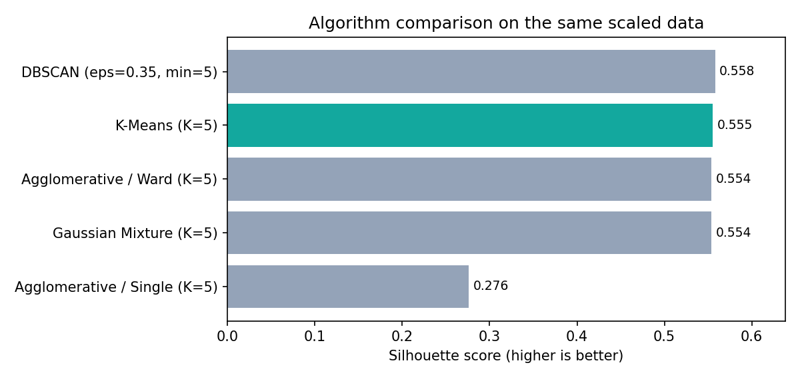
Figure 2: Silhouette score of each algorithm on identical data
What the results show, and why:
- K-Means, Ward and Gaussian Mixture are effectively tied (0.554 to 0.555). A difference of 0.001 is not meaningful. The honest conclusion is that this dataset is easy: the five groups are compact, roughly round and of similar spread, which is exactly the situation K-Means assumes. A more flexible model such as a Gaussian Mixture (which allows elliptical clusters) has nothing extra to capture. Ward linkage minimises the same variance criterion as K-Means, so it finds almost the same partition.
- Single linkage is far worse (0.276). It merges clusters through chains of nearby points, so a few bridging customers between groups can join them together or leave stray points as tiny clusters. It suits elongated shapes, not blob-like segments.
- DBSCAN scores marginally higher, but partly because it sets aside 23 customers in low-density regions as noise and returns six clusters. For a mall, ignoring more than one customer in ten is not acceptable, since every customer should receive a segment. DBSCAN is also very sensitive to eps, and scikit-learn's version cannot assign a new customer to a cluster, which an API needs.
- K-Means was therefore chosen for practical reasons rather than because it won: it matches the data's shape, gives every customer a segment, offers a predict() method for the API, is fast, and its centroids are easy to explain to marketing staff. Gaussian Mixture would be a good alternative if soft (probability) assignments were wanted.

4.6 Which features? Experiment
K-Means with K = 5 was repeated on different feature combinations, all scaled.
Feature set | Silhouette | Davies-Bouldin
Income + Spending (used) | 0.555 | 0.572
Age + Spending | 0.448 | 0.757
Income + Spending + Age | 0.417 | 0.875
Age + Income | 0.396 | 0.839
Income + Spending + Age + Gender | 0.304 | 1.167
The cluster structure lives entirely in the Income and Spending Score plane. Age is only weakly related to those two variables (r = -0.33 and -0.01), so adding it gives K-Means an extra dimension with no group structure, which blurs the compact clusters and drops the silhouette from 0.555 to 0.417. Gender, being binary and unrelated to the segments (Section 6.3), adds still more noise (0.304). This supports using two features and keeping Age and Gender out of the model.

4.7 Does scaling matter here?
The model was also trained on the raw, unscaled features. It produced exactly the same segments (adjusted Rand index 1.0). The reason is that Income and Spending Score already have nearly the same standard deviation (26.3 and 25.8), so neither dominates the distance calculation. Scaling is retained in the pipeline because it costs nothing and protects the model if features with different units, such as Age, are added later.

4.8 Stability
K-Means can converge to different answers depending on initialisation. The model was retrained with 10 different random seeds and each result compared with a reference run using the adjusted Rand index. Every run gave an index of 1.0, meaning the segments are identical regardless of the seed, so the result is not an accident of one lucky start.

5. Results

5.1 Evaluation
Metric | Value
Number of customers | 200
Number of clusters | 5
Silhouette score (higher is better) | 0.555
Davies-Bouldin index (lower is better) | 0.572
A silhouette score above 0.5 indicates clearly separated clusters. Because K-Means is unsupervised there is no accuracy figure; quality is judged with these two metrics and with the business meaning of each segment.

5.2 Customer segments
Segment | Customers | Avg age | Avg income (k$) | Avg spending
Average Shoppers | 81 | 42.7 | 55.3 | 49.5
Premium Shoppers | 39 | 32.7 | 86.5 | 82.1
Careful Spenders | 35 | 41.1 | 88.2 | 17.1
Budget Customers | 23 | 45.2 | 26.3 | 20.9
Impulsive Spenders | 22 | 25.3 | 25.7 | 79.4
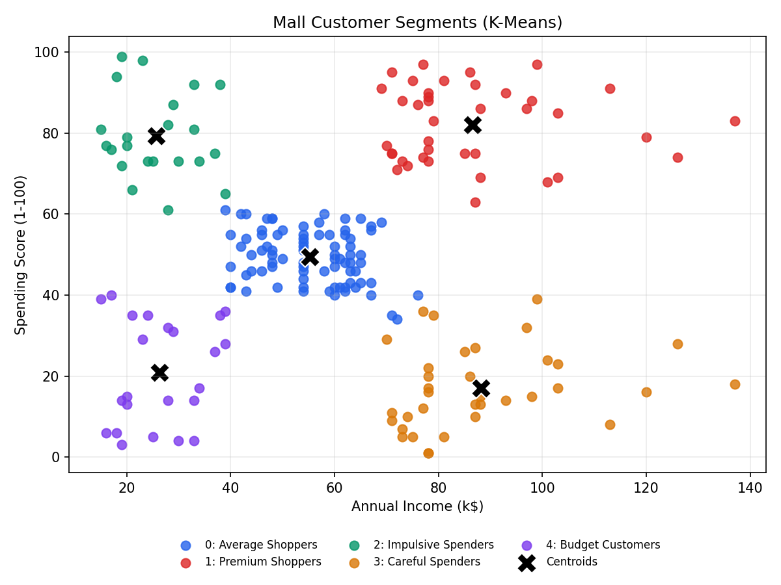
Figure 3: The five customer segments and their centroids

5.3 Business interpretation
- Premium Shoppers (high income, high spending): loyalty rewards, VIP events and premium launches.
- Careful Spenders (high income, low spending): personalised offers and quality-focused campaigns to raise engagement.
- Impulsive Spenders (low income, high spending): trending items, flash sales and instalment offers.
- Budget Customers (low income, low spending): discounts, coupons and value bundles.
- Average Shoppers (mid income, mid spending): seasonal promotions and cross-selling.

6. Bias, Ethics and Responsible Use
Customer segmentation directly affects how people are treated, for example who receives offers, so the model was checked for bias and its risks are documented here rather than ignored. The numbers below come from compare_models.py (outputs/segment_fairness_check.csv).

6.1 Sampling and representativeness
The file contains 200 customers of a single mall. It does not say how they were chosen, for what period, or whether they are loyalty-card members only. If the sample favours certain shoppers (for example card holders, or people present on weekdays), the segments describe that group, not all customers. The results should not be generalised beyond this dataset without validating them on larger, documented data.

6.2 The Spending Score is a black box
The Spending Score is assigned by the mall and its formula is unknown. The model learns this score, not real behaviour. If the score systematically favours some shoppers, for instance those who visit often or use a loyalty card, that bias passes straight into the segments. The mall should document how the score is built and audit it.

6.3 Gender: excluded, and checked
Gender was deliberately not used as a model feature. Exclusion alone does not prove fairness, because other features can act as stand-ins, so the make-up of each segment was also examined.
Segment | Customers | % Female | % Male | Avg age
Average Shoppers | 81 | 59.3 | 40.7 | 42.7
Premium Shoppers | 39 | 53.8 | 46.2 | 32.7
Careful Spenders | 35 | 45.7 | 54.3 | 41.1
Budget Customers | 23 | 60.9 | 39.1 | 45.2
Impulsive Spenders | 22 | 59.1 | 40.9 | 25.3
All customers | 200 | 56.0 | 44.0 | 38.8
A chi-square test of independence between gender and segment gave p = 0.693, so there is no evidence that gender is related to segment membership. Each segment's gender split is within about 10 percentage points of the overall 56/44 split. With only 22 to 81 customers per segment, small differences cannot be called significant either way.

6.4 Age as a hidden proxy
Age was also excluded from the model, but the segments are strongly shaped by it. Impulsive Spenders are aged 18 to 35 (average 25.3), Premium Shoppers are aged 27 to 40, while Budget Customers average 45.2 and Average Shoppers range from 18 to 70. This happens because Age is correlated with Spending Score (r = -0.33). The risk is that treating people by segment becomes, in practice, treating them by age, for example offering premium events only to a younger group. Age-based discrimination in pricing, credit or access to services is restricted in many jurisdictions, so segment membership must never be used to decide prices, credit or whether someone is served.

6.5 Labels and dignity
Names such as "Budget Customers" or "Impulsive Spenders" are shorthand for marketing staff but can stereotype people. A customer's segment describes recent income and score values, not their character, and people move between segments over time. Segment names should stay internal, and customer-facing communication should be neutral and respectful.

6.6 Privacy and consent
The dataset has no names or contact details, but combining ID, age, gender and income can still make a person identifiable. Profiling customers generally requires a lawful basis, purpose limitation and often consent under data-protection laws such as the GDPR and India's Digital Personal Data Protection Act, 2023. The deployed API stores nothing: the income and score sent to /predict are used to compute the answer and are not saved or logged by the application.

6.7 Model limitations that affect people
- Hard assignment: a customer near a boundary (for example income 70, score 50) is placed in one segment with no indication of uncertainty. A future version should report the distance to each centroid or use a Gaussian Mixture to give probabilities.
- Segments are descriptive, not causal: the model shows who looks similar, not why they spend as they do.
- Drift: customer behaviour changes, so segments need to be refreshed and re-audited on a schedule.

6.8 Summary of safeguards
Risk | Done in this project | Recommended next
Gender bias | Gender excluded; segment make-up tested (p = 0.693) | Repeat the audit after each retraining
Age proxy | Documented and quantified | Never use segments for pricing, credit or service
Biased Spending Score | Identified as an unknown | Obtain and audit the score formula
Unrepresentative sample | Stated as a limitation | Retrain on larger, documented data
Privacy | API stores no inputs; no names in data | Obtain consent; set retention rules
Stigmatising labels | Neutral recommendations in the app | Keep segment names internal
Over-trusting output | Limitations documented | Human review; show uncertainty

7. Model Serialization
After training, the whole pipeline (scaler plus K-Means) is saved with Joblib so the web application never needs to retrain. A metadata.json file stores the feature names, segment names, profiles and metrics.
joblib.dump(pipeline, "models/customer_segmentation.joblib")

# in app.py
model = joblib.load("models/customer_segmentation.joblib")
cluster = model.predict(X)[0]

8. Deployment with Flask
app.py loads the serialized model once at start-up and exposes the following routes.
Method | Route | Purpose
GET | / | Web interface with a prediction form and a segment summary table
GET | /health | Health check used by hosting platforms
GET | /api/info | Model details, segment names and profiles as JSON
POST | /predict | Predict the segment of one customer

8.1 Prediction API example
POST /predict
{ "annual_income": 90, "spending_score": 85 }

200 OK
{ "cluster": 1, "segment": "Premium Shoppers",
"recommendation": "High income and high spending. ..." }

Input is validated: missing, non-numeric or out-of-range values return HTTP 400 with a clear error message. Unknown routes and wrong methods return JSON errors instead of HTML error pages.

8.2 Web interface
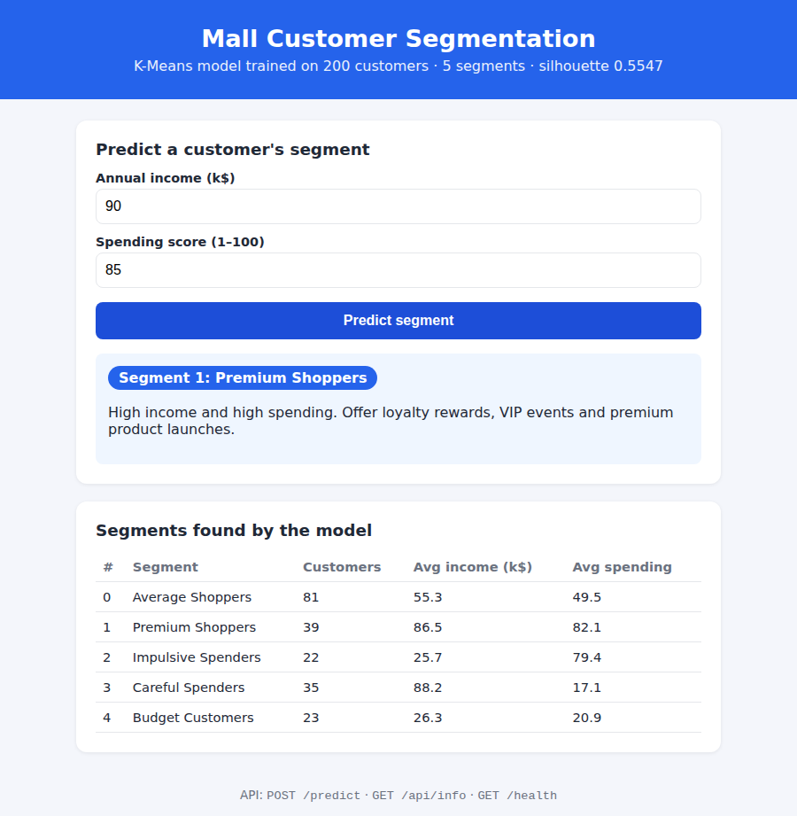
Figure 4: The running application predicting a Premium Shopper

9. Testing
The tests/test_app.py file contains 17 automated pytest tests, all of which pass. They cover:
- The home page, health check and model-info endpoints.
- One representative customer for each of the five segments.
- Numeric strings accepted as input.
- Six kinds of invalid input (empty, missing field, text, negative income, score of 0, score above 100).
- Non-JSON requests, wrong HTTP method and unknown routes.
The application was also started with python app.py and checked with real HTTP requests using curl and a headless browser.

10. Running and Deploying

10.1 Run locally
python -m venv .venv
.venv\Scripts\Activate.ps1
pip install -r requirements.txt
python train_model.py
python compare_models.py # optional: experiments
python app.py # http://127.0.0.1:5000
pytest -q

10.2 Deploy to the cloud
The project includes a Procfile (gunicorn app:app) and a render.yaml file. To publish it: push the folder to GitHub, create a new Web Service on Render, connect the repository and deploy. The build command installs the requirements and trains the model, and /health is used as the health check. Railway and Heroku can use the same Procfile.

11. Limitations and Future Work
- Only income and spending score are used for clustering; adding Age and Gender could reveal finer segments.
- 200 customers from one mall is a small, undocumented sample; segments should be re-checked on more data (Section 6.1).
- Age and Gender are excluded from the model, yet Age still shapes the segments; fairness must be re-audited after every retraining (Section 6.4).
- K-Means assumes roughly round clusters; alternatives such as Gaussian Mixture Models or DBSCAN could be compared.
- Future work: batch prediction from CSV upload, a Docker image, logging and monitoring, and scheduled retraining.

12. Conclusion
The project delivers a complete machine learning workflow: validated data, a K-Means pipeline with a silhouette score of 0.555, a Joblib-serialized model, a tested Flask web application and API, deployment configuration and documentation. The alternatives (Gaussian Mixture, hierarchical clustering, DBSCAN) were compared honestly, the feature choice was supported by experiment, and bias and ethical risks were examined and documented. A business user can enter a customer's income and spending score and immediately receive their segment together with a marketing recommendation.

